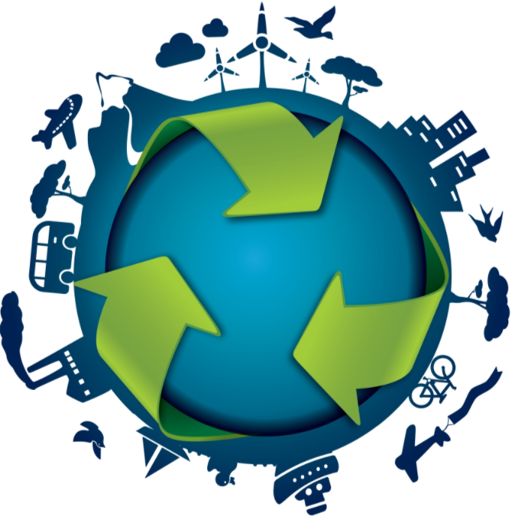

Circular Economy
VZ20A

Contents
1. Circular Economy and what it is all about 2
2. But how can we even be part of the natural cycle? 2
3. The four principles of circular economy 3
4. Why we need circular Economy 4
5. From linear to circular economy 6
6. What is circular economy? 7
7. Cycles in Circular Economy 7

Circular Economy and what it is all about

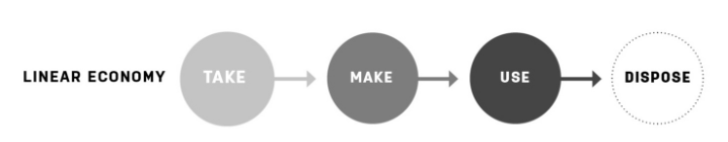
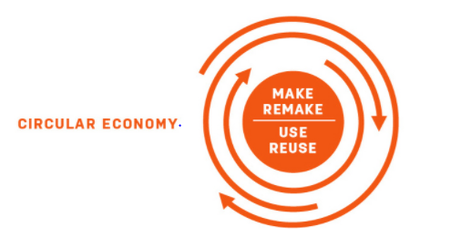
This is what we do with goods and resources. We mine and take them only for use and then again disposal.
But because our economies have become too large to just dispose of every good we harvest or mine, we need a new plan. This is the circular economy. It aims to radically limit the extraction of raw materials and the product of waste. The main idea of circular economy is to use and also reuse and recycle the resources we got in order to use them again instead of trying to get more and more until the system collapses.
Nature already does have a cycle it sticks to hand has sticked to for centuries. Animals eat the plants and bigger animals eat these animals again. Whereas when the bigger animal dies, it turns to soil which again ends with a plant and so on. Humans on the other hand, we disrupt this cycle by buying new things as soon as there is a better version of the old. By doing that, we are emptying our natural resources without giving it the chance to recharge.

But how can we even be part of the natural cycle?
If we invest in products, we should make sure that at least the wrapping or even the product itself is recyclable or biodegradable. This would already be a great start. Well of course we cannot make a washing machine biodegradable. so, what we can do we can reuse these parts of the machine to build another one or a different object. This process would create a technical cycle.
Merging these ideas together we have a sustainable plan to heal what has been broken and to recycle what has been used.
Let’s say for example: A company manufactures business chairs. After it has been used for some time the owner would like a new one. Now the company who produced it would take it back and give the customer a discount on a new one.
The company also takes care of the disposal of the old chair. The parts of the chair are taken apart and get disposed in a sustainable way, the way they are supposed to.

The four principles of circular economy

- Waste = food One species waste becomes another species food
- Build resilience through diversity
- Work with energy from renewable sources (such as the sun) = These principles could create a system that would enhance our way of living incredibly.
- We need to think in systems! (only if we think in systems we can enhance society, environment and economy)
Circular economy is about many actors and factors working together to create effective flows of material and information. With everything increasingly powered by renewable energy.
Examples of the four principles

Waste=Food
This principle considers the continuous cycling of materials and products. A material or product that is no longer used shouldn't become 'waste', but instead should be part of a new cycle of use.
Natural system, example: Birds eat berries. Bird droppings contain berry seeds. The bird droppings also act as a fertiliser for the seeds, enabling these to grow into plants. Bird 'waste' is ‘food’ for berry plants.
Man-made system, example: I drink wine from a glass bottle. When the bottle is empty I throw it in the glass recycling bin. The bottle is crushed, melted and formed into a new glass bottle. Glass bottle 'waste' therefore becomes ‘food’ for new glass bottles.

Build resilience through diversity
Diverse systems i.e. systems with many different components, are more resilient. Resilient is defined as being capable of dealing with change while continuing to develop. This is particularly true if the components of a system respond differently to change and disruption. A particular disturbance is then unlikely to present the same risk to all components at once.
Natural system, example: A jungle.
Man-made system, example: An organic farm with mixed crops (not one crop, but a variety of different foods).

Energy from Renewable Resources
The sun is one of the major sources of renewable energy (wind power, tidal power and plant growth directly derive from sunlight), but not the only one. The other source is geothermal heat, generated deep within the earth.
Natural system, example: A green plant (sunlight converts CO2 and water into sugars: photosynthesis).
Man-made system, example: A solar cell (sunlight is converted into electricity).

Think in Systems

Natural system, example: The food chain. If one species goes extinct, it can affect many other species, because they are interdependent in complex ways.
Man-made system, example: Unexpected effects. We now have energy saving light bulbs. We feel good about these, because they save electricity. But now we are putting these light bulbs in places that were not illuminated before (gardens, for instance). As a result we are not saving as much electricity as we had expected.
Can you come up with better examples? Share your examples in the discussion below and enjoy the input from your fellow learners. Don't forget to come back to check whether someone has replied to your post, and join the conversation!

Why we need circular Economy
To limit the extraction of raw materials and reduce the production of waste
In the post war era, we could have things and pay later which lead to a massive boom. The fact, that this system is not there anymore is proof, that we change economy.

How resources are increasingly difficult to extract

With mining and digging we are able to collect important materials and goods from way underground. The goal is to make good use of these, so to make good and practical materials with a lucrative price out of them. But what is the problem with linear economy like this?
A linear Economy relies on cheap energy, cheap materials and cheap credit to get the throughput. Which means, that the companies can make ends meet with their costs of production and people who work in these companies. Sadly, the environment which we extract the materials from, is not being taken care of.
We need an economic system that does help the environment. September 2008 taught us things, when the financial system was collapsing. This crisis turned the economy upside down.

The Linear Economy is not working very well. There are three reasons:
  - Resources like fossil fuels, food and water are increasingly hard to get.
  - Biodiversity is in decline worldwide. Yet ecological services provided by the natural world seem to be taken for granted.
  - The financial system almost crashed the entire economy.

Why is it difficult for companies to be innovative?
The competition is so high and intense, that it has become more and more difficult for companies to sell their products. It has become critical for companies to male good profits or even survive. The other side is that customers can’t be easily persuaded to buy a certain product that offer fair trade or other environmentally friendly.

MAIN TAKEAWAYS
  - Real wages have been stagnant or falling for several decades.
  - This has resulted in intense competition among companies selling products and services, and in an unfavourable market position for environmentally or socially benign products (these often cost more).
  - The 3 billion new customers entering the market in the next 20 to 30 years will put an enormous pressure on the resource base if we continue along our current, linear ways.

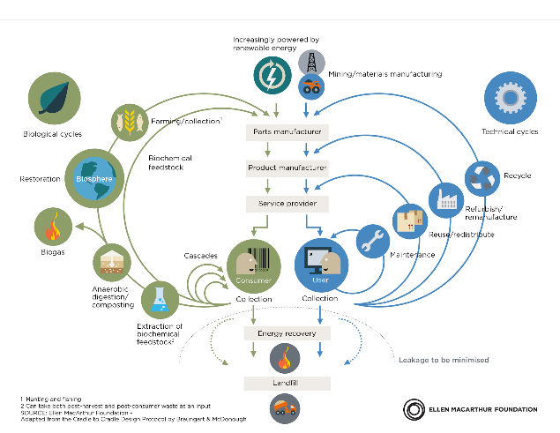
Hoe circuleren materialen in een circulaire economie? - Kenniskaarten - het Groene Brein

From linear to circular economy
When we transition from a Linear to a Circular Economy, the assumptions underlying the Linear Economy fall away, only to be replaced by a new set of assumptions for a Circular Economy. Have a look at these word pairs:
In a Linear Economy, waste is a logical consequence of the take-make-use-dispose model. In a Circular Economy, however, we no longer think about 'waste' as something without value. Instead, we regard waste as a resource for new processes. Metaphorically speaking, in a Circular Economy waste becomes 'food' for new processes. Words such as ''round put'', ''remake'', etc., can become part of the narrative behind the Circular Economy.

What is circular economy?
The Circular Economy System Diagram, also known as the 'Butterfly Diagram', represents flows of products and materials in the Circular Economy.
The diagram starts from the current Linear Economy, depicted as the central, downwards flow from materials extraction and manufacturing at the top to incineration and landfill at the bottom. In the Circular Economy, resources are used, but not used up. By applying suitable strategies to products, components and materials during use and after the end of a lifecycle, resources are kept in the system.

Cycles in Circular Economy
In a circular system, technical and biological nutrients, or materials, are retained in continuous loops. The circular flow of these nutrients is represented by the loops on either side: green for biological and blue for technical nutrients.
Biological materials can be safely returned to the biosphere and add value to the environment, once they have gone through one or more use cycles. These materials include food, natural fibres and bio-based materials, such as wood.
Technical materials cannot be returned to the biosphere. These materials should continuously cycle through the system so that their value can be (re)captured. These materials include plastics, metals and synthetic chemicals.
Scroll through the slides below to explore the Butterfly Diagram in detail. The Butterfly Diagram is the backbone of this course. In the coming episodes, you'll be introduced in more detail to the different loops.

Industrial Ecology
- Industrial Ecology is concerned with the study of material and energy flows through industrial systems.
- Industrial Ecology and the Circular Economy share similar goals and principles.

The linear Economy
In this post we are not really going into circular economy. We are focusing on the opposite of circular economy, the linear economy.
The main goal of circular economy is to reuse and recycle the materials of a product, whereas linear economy does not take care of the environment like that. Linear economy simply produces products with certain materials and does not resue them.

How resources are increasingly difficult to extract / linear economy

With mining and digging we are able to collect important materials and goods from way underground. The goal is to make good use of these, so to make good and practical materials with a lucrative price out of them. But what is the problem with linear economy like this?
A linear Economy relies on cheap energy, cheap materials and cheap credit to get the throughput. Which means, that the companies can make ends meet with their costs of production and people who work in these companies. Sadly, the environment which we extract the materials from, is not being taken care of.
We need an economic system that does help the environment. September 2008 taught us things, when the financial system was collapsing. This crisis turned the economy upside down.

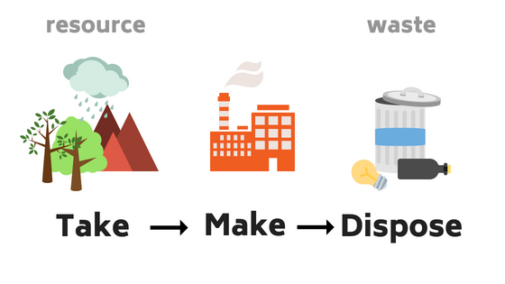

The Linear Economy is not working very well. There are three reasons for this:
  - Resources like fossil fuels, food and water are increasingly hard to get.
  - Biodiversity is in decline worldwide. Yet ecological services provided by the natural world seem to be taken for granted.
  - The financial system almost crashed the entire economy.

Why is it difficult for companies to be innovative?

The competition is so high and intense, that it has become more and more difficult for companies to sell their products. It has become critical for companies to make good profits or even survive. The other side is that customers can’t be easily persuaded to buy a certain product that offers fair trade or other environmental friendly.
  - Real wages have been stagnant or falling for several decades.
  - This has resulted in intense competition among companies selling products and services, and in an unfavourable market position for environmentally or socially benign products (these often cost more).
  - The 3 billion new customers entering the market in the next 20 to 30 years will put an enormous pressure on the resource base if we continue along our current, linear ways.

