Project Titel: Littering

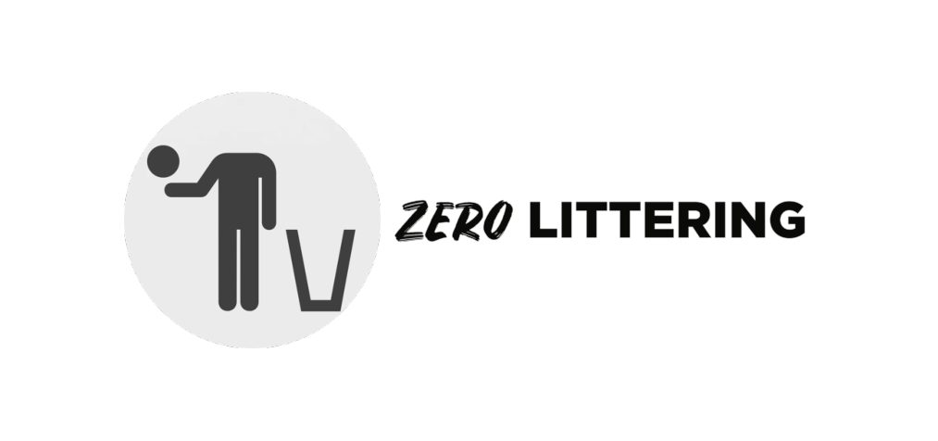

What impact does littering have on society? What solutions can be taken against it?
Why did I choose this topic?
The topic is very topical and is not taken as seriously as it should be. I was interested to find out whether the Swiss notice littering and what their own attitude to littering is. I also worked with students from the Basque Country. They also have a project about littering, but littering on the beach and in the sea.
What is my goal with my project?
I want to sensitise people to stop throwing litter on the ground. I also want to inform people about the consequences of littering.
Who will I interview?
Swiss citizens on the streets of Zurich.
Age groups: varying from 15 - 60 years old.
Introduction
I have chosen the topic of littering because it is an issue that I believe is too neglected in our society. Through this project, I would like to sensitise readers to the issue of littering. Littering is a widespread problem in Switzerland and costs the state a lot of money every year.
In addition, I would like to know how to minimise the littering problem and which municipalities in the Canton of Zurich are most confronted with littering problems. I argue that sanctions or more education of the population can reduce the littering problem.
I would like to answer the following questions in this project:
- What is littering?
- What impact does littering have on the environment?
- What measures can be taken against littering?

What is littering?
Littering is the careless throwing away or leaving of waste, which is becoming more and more of a problem in public spaces. Many municipalities are looking for suitable measures to combat littering.
"Littering" is understood to mean the soiling of streets, squares, parks or public transport by carelessly or deliberately dropped and left litter. Even if, in absolute terms, comparatively small amounts of waste are left on the ground, the majority of the population finds this disturbing." (Federal Office for the Environment FOEN, 2017)
Depending on the type of waste that is left behind, this also gives rise to different types of problems, nuisances or dangers, such as hygienic, ecological impairments or impairments to the desired order. Odour nuisance usually includes dog excrement or, in the case of a place, the people living there. It can also cause a risk of accident, such as slipping on a banana peel.
Here I have made a diagram showing what types of litter are most often thrown away:

Diagram; Types of waste
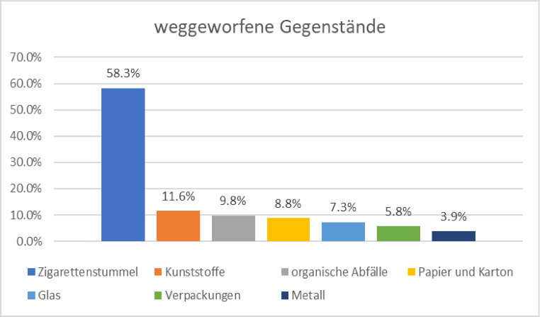

According to a survey carried out in Switzerland, littering is very disturbing for the whole of humanity, as it affects the quality of life as well as safety in a public space. Depending on the canton, littering is also a punishable offence, but unfortunately there is still no law that would encourage people to be more economical and careful with their waste and to dispose of it correctly.
Background to littering
The causes of the rising tide of littering are manifold. Littering waste mainly comes from the take-away and beverage sector. More and more people spend their lunch break at their place of work or education and eat on the go. Many people don't think about the large disposal charges they incur when they leave litter lying around. Another reason for littering is that there is little social control in public spaces. Anonymity increases the likelihood of littering. Group effects increase this even more, mostly littering is used among young people as a means of expressing coolness. Littering is strongly determined by location and personal values.
Another increasing trend is the boom of free newspapers, which are often thrown away after a short time or left somewhere between the tram and the park. Another factor is the throwing away of cigarette butts, which has increased in recent months due to smoking bans in bars and restaurants. However, it can be said that objects that have value are not left lying around and places with which there is a personal connection are not littered. (Federal Office for the Environment FOEN, 2017)
The different types of littering
There are different motives that lead to littering. I have taken these from a graphic of the IGSU (IG Clean Environment). According to the motivation, different types of littering can be recorded, which I have listed here.
These are divided into three categories: Non-Litterers, Occasional-Litterers and Heavy-Litterers.
The non-litterer includes the cautious and the environmentally conscious. The cautious person tends to feel observed and does not want to be caught. The environmentally conscious one simply does not throw anything away out of conviction.
After that we have the occasional litterers. We have a few more of these:
- The cool one who doesn't let anyone tell him what to do.
- The anti-nerd: that's the one who doesn't want to make a fool of himself with colleagues.
- The unconcerned one who simply thinks nothing of it. For him, littering just happens.
- The smart dropper who finds a niche everywhere. A place for litter, so to speak.
- The Stress Dropper, who has no time to dispose of litter properly.
Finally, there are the heavy litterers. We have three of these:
- The Hardcore Litterer, who sees littering as part of the action. Littering is fun for him.
- The expedient one, who sees no reason to dispose of the rubbish correctly, since it is disposed of by the cleaning crew anyway.
- Not to forget the job broker: that's the one who thinks littering creates jobs.
(IG Clean Environment)
- Furthermore, two forms of littering are distinguished:
- - Active littering: People deliberately leave litter lying around or throw it on the ground.
- - Passive littering: People drop something out of their pockets or litter is forgotten.
- Consequences of littering
- Of course, littering also has certain consequences. This can be divided into three different categories.
- One of these categories is the aesthetic impact: Cleanliness is very important for the population and their quality of life. Littering pollutes people's living space and can be harmful to their health. It is also a threat to animals and plants.
- It also damages the image of a city or other public space. Littering is thus a visual nuisance and disturbs people's quality of life.
- The second category includes the ecological impact: Since the discarded materials cannot be used for recycling, they cannot be returned to material cycles. New resources must therefore be obtained and processed.
- The third category is the economic impact: As already mentioned, littering generates high costs. Cleaning costs of about 200 million Swiss francs have to be reckoned with annually. However, these are not the only costs. There are also high costs for prevention measures and education campaigns. These are there to make people more aware of the issue of littering, as many are not aware of it. (Federal Office for Waste, FOEN)

What measures can be taken against littering?
There are various possible measures to prevent littering.
Littering can only be effectively combated if various measures are taken in combination. The measures that have the greatest effect are those that address human behaviour. The mix of measures is decisive.
For entrepreneurs, application-oriented workshops on specific topics related to littering can be offered. At the workshops, various topics can be discussed and deepened in a practice-oriented manner. Visits and practical examples are an integral part of this.
Public relations work and awareness-raising can take place via advertising posters, advertisements, anti-litter ambassadors or jointly organised cleaning campaigns in the communities and neighbourhoods. There is also an environmental interest group called IGSU. In primary and secondary schools, there should be waste lessons for environmental education. There could also be packaging minimisation so that there is less waste.
Information and education is very important, especially among young people. So is building up environmental knowledge and concrete action skills. Various organisations offer teaching materials or school visits to show children and young people how to use natural resources responsibly.
Youth work, as well as school campaigns, cleaning around points of sale and at events would be the best options for waste management. Sanctions such as awareness-raising and information work make sense, but do not always have the desired effect on people.
In order to stop littering, those suspected of littering can be given a fine. There should be more video surveillance and more police officers on patrol to prevent littering. That is why in some cantons and cities the legal basis for a littering fine has been created. Other cities deliberately do without fines because this sanction is not feasible in reality.
This is how much the cantons and cities are paying today
Fines for littering, in Francs
Cantons
Appenzell Innerhoden 100
Basel-City 80
Bern Lucerne Solothurn 40 to 80
St. Gallen 50
Thurgau 50 to 80
Zug 100
Zurich cities
Bülach 100
Winterthur 50
Zurich 80

FOEN study: Littering costs
As already mentioned briefly in the section on the consequences of littering, the deliberate dropping and leaving of litter on the road causes additional costs for the municipalities. The FOEN, Federal Office for the Environment, had conducted a study on this in 2010. They wanted to find out how the costs are allocated to the most significant littering fractions. So they carried out a nationwide study. Littering causes direct as well as indirect additional costs, most of which are borne by the public sector. The FOEN study recorded the additional litter-related costs of cleaning. Other additional costs, such as for additional preventive measures, are not taken into account here. The costs caused by littering and their allocation to the respective littering fractions were determined on the basis of random samples in 40 municipalities and at 9 public transport companies. According to the FOEN, more than 50% of the littering costs in municipalities are caused by food and drink packaging as well as other objects such as napkins, plastic cutlery, etc. Another large proportion of the costs is caused by the fraction of littering that is not used for public transport. Cigarettes also account for a large proportion of the costs (36%). This high cost share of cigarettes can be explained by the fact that small parts on natural surfaces such as lawns, gravel, tree grates and hedges require a great deal of cleaning.
(Federal Office for the Environment FOEN, 2017)

My own experience

In my own experience here in Zurich, there are many places that are affected by littering. Usually it is at the weekend after people have partied and have not been able to dispose of their rubbish. Probably the most affected place by littering in Zurich is the lakeside promenade on Lake Zurich. The age groups responsible for littering are often between 12 - 20 years old. These children or young people do not know how troublesome it is to dispose of the litter. They only think about partying.

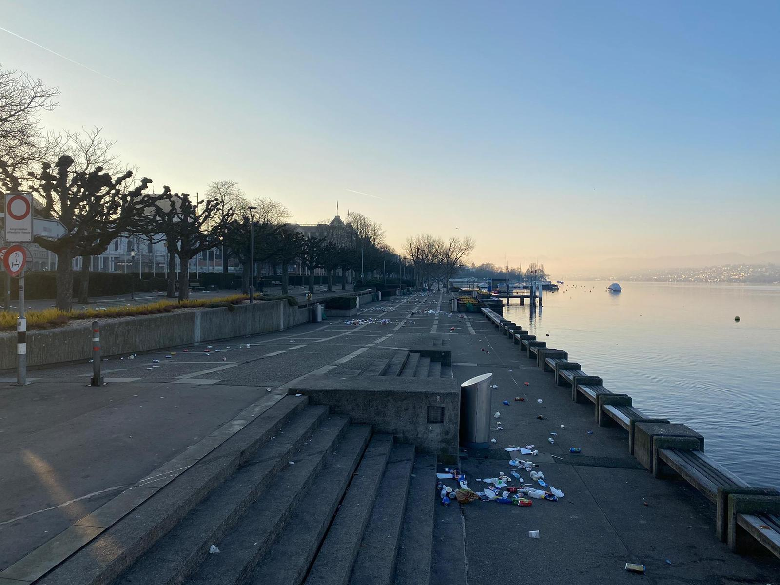

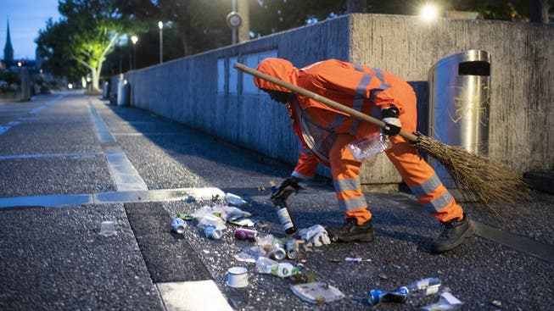
I know that the cleaners of the city of Zurich start cleaning the whole city at 3 - 4 o'clock in the morning, so that the next day you think that nobody was there. These cleaners deserve respect because it is very exhausting to pick up and dispose of all the rubbish.
Conclusion
Switzerland is supposedly the second cleanest country in the world, yet in this project I found out that Switzerland has a littering problem that needs to be addressed. Littering is difficult to prevent and if you want to reduce it, you have to raise awareness. The interesting problem with littering is that people throw litter on the ground when there is already litter there. Subsequently, less litter is thrown on the ground when there is already no litter on the ground.
When I started the project, I started with the assumption that there was no big littering problem in Switzerland. However, I soon realised that I was wrong, at the latest when I saw the high government expenditure per year to fight littering. I realised that littering is a topic that is not addressed enough. With this project I want to sensitise people about the littering problem.
It was exciting for me to write this paper. I was able to follow up on my assertions and delve even deeper into the topic.

- Survey
- I created a survey in which 15 people on the streets of Zurich took part.
- Age groups 15 - 60
- You were asked the following questions:
- 1. do you feel that Switzerland has a littering problem?
- 2. do you throw litter on the ground yourself?
- 3. what do you recycle?
- 4. are you satisfied with the packaging of the retailers? If not, what could be done better?

- Below are the participants' answers:
- Person 1:
- 1. no
- 2. no
- 3. pet and waste
- 4. No, because it has way too much packaging.
- Person 2:
- 1. yes
- 2. yes
- 3. pet and aluminium
- 4. no. Don't use so much plastic.

- Person 3:
- 1. yes
- 2. no
- 3. aluminium, glass and pet
- 4. you could save on plastic for certain packaging.
- Person 4:
- 1. yes
- 2. no
- 3. everything
- 4. not everything would have to be wrapped in plastic.
- Person 5:
- 1. no
- 2. yes
- 3. pet, aluminium and glass
- 4. introduce organic packaging.

- Person 6:
- 1. yes
- 2. no
- 3. cardboard, paper, pet, aluminium, glass and batteries
- 4. no, material could be saved in almost all packaging.

- Person 7:
- 1. yes
- 2. no
- 3. glass and pet
- 4. you could certainly save on material for some packaging.
- Person 8:
- 1. yes
- 2. no
- 3. pet, can, aluminium, glass and batteries
- 4. I think it wouldn't take much effort to save some plastic.
- Person 9:
- 1. yes
- 2. no
- 3. pet, aluminium, cans, glass, batteries, carton
- 4. no, plastic could be saved on practically all edibles.
- Person 10:
- 1. yes
- 2. no
- 3. pet, aluminium, glass, paper, cardboard and electronics
- 4. saving on packaging would require more effort, but it would be possible.

- Person 11:
- 1. yes
- 2. no
- 3. pet, glass and aluminium
- 4. no, one could use less plastic packaging.
- Person 12:
- 1. no
- 2. no
- 3. everything
- 4. no. I have no suggestion for improvement.
- Person 13:
- 1. no
- 2. very rarely
- 3. glass, aluminium, pet and cardboard
- 4. yes actually.
- Person 14:
- 1. no
- 2. sometimes cigarette butts
- 3. aluminium, pet, glass and paper
- 4. yes.

- Person 15:
- 1. yes
- 2. no
- 3. the usual
- 4. no, one could use more environmentally friendly packaging.

- I was able to draw the following conclusions from the survey:
- - Majority of respondents think that Switzerland has a littering problem.
- - Large majority of respondents do not litter themselves
- - Every participant recycles
- - Many of the respondents think that more plastic can be saved in the packaging used by retailers.

List of sources/literature
Bundesamt für Abfall BAFU. (06. 06. 2017). Von Auswirkungen:
https://www.bafu.admin.ch/bafu/de/home/themen/abfall/fachinformationen/abfallpol itik-und-massnahmen/littering.html abgerufen
Bundesamt für Umwelt BAFU. (06. 06. 2017). Von Littering kostet
https://www.bafu.admin.ch/bafu/de/home/themen/abfall/fachinformationen/abfallpol itik-und-massnahmen/littering.html abgerufen
IG saubere Umwelt. (kein Datum). Von IGSU: http://www.igsu.ch/de/littering/littering- typen/ abgerufen
Tagesanzeiger. (14.11.2014). Von Littering soll überall strafbar werden:
https://www.tagesanzeiger.ch/schweiz/standard/Littering-soll-ueberall-strafbar- werden/story/29973630 abgerufen
NZZ. (16. 06 2016). Von Bussen für Littering überraschend abgelehnt:
https://www.nzz.ch/schweiz/aktuelle-themen/umweltverschmutzung-nationalrat- gegen-littering-bussen-ld.89366 abgerufen
Wikipedia (kein Datum). Von https://de.wikipedia.org/wiki/Vermüllung

Project Basqueland:

